HMIS for Call Center Staff
Step 1: You receive a call from someone in a housing crisis.
- Log into HMIS.
- Click on Client Management, Bucks County Housing Link.
- Click on New Intake.
- Enter the Date of the Call and select Single Person from the dropdown labeled Intake Type.
- Then click Continue.

- The household quick-entry tool will appear. This tool allows you to quickly enter the caller’s Name, Date of Birth, Social Security Number, and Gender. Enter this information into the text boxes as appropriate.

If the person does not want to provide their date of birth or social security number, check the checkbox next to the right of the textbox.
- Then click Save.
- Now your screen will look like this:
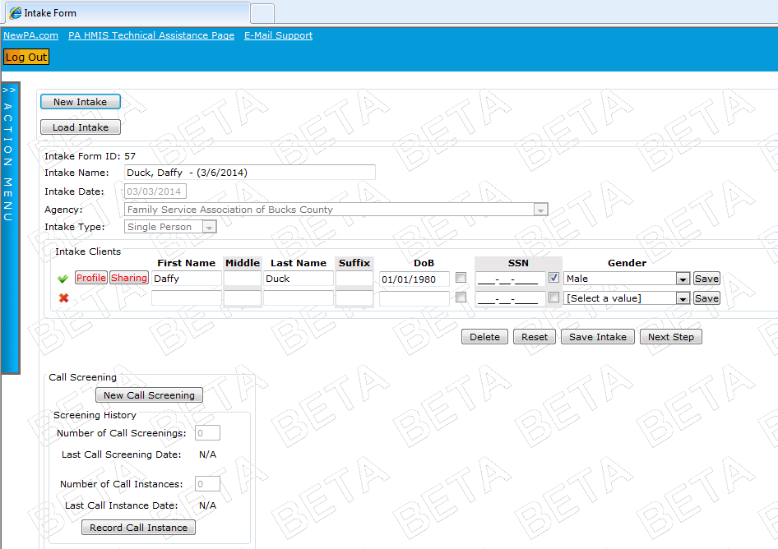
- Click on the button labeled New Call Screening.

- Now the Call Screening form will appear. It will look like this:
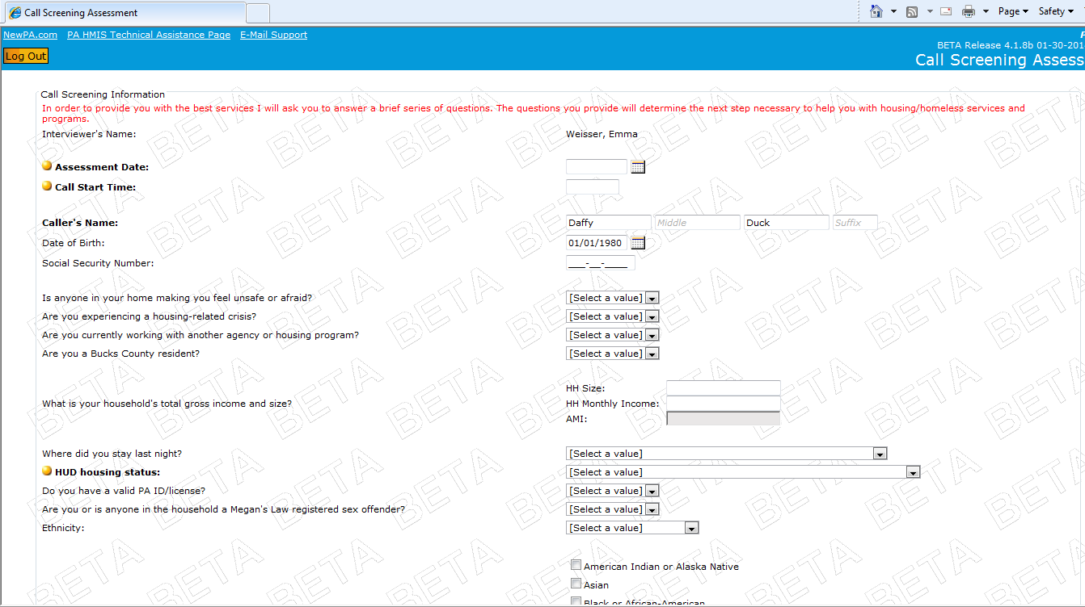
Complete the Call Screening with your client.
Make sure to enter the appropriate time (12 hour) into the Call Start Time box.
- At the end of the Call Screening, you can add brief notes about the situation. Then, enter the Call End Time.
Finally, select the Result of Call from the dropdown menu. Click Save.
- If your Result of Call is to refer to the Housing Link Coordinated Assessment, click the button labeled Next Step.
- A pop-up will appear, asking what you would like to do next. Select the button labeled Refer Client.

- You’ll be taken to the referral page. Note that this is actually in the client’s profile.
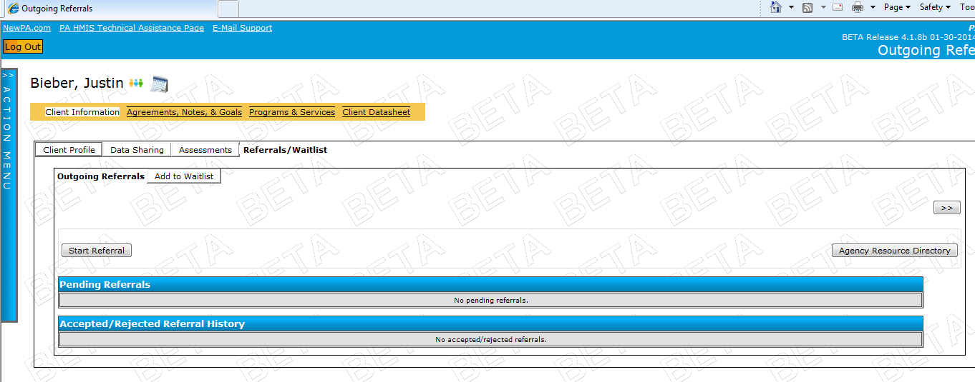
Look familiar?
- Click the button Start Referral.
- The referral grid will now appear. Select your Site and the Referral Type (services only). Then select Coordinated Assessment from the dropdown menu labeled Add Program Type.
- Click the button labeled + .
- Now select the agency you are referring to, and click Continue.

- A confirmation page will appear. Click Continue.

- The final confirmation page will appear. Select the appropriate staff person to send the referral to by clicking the button labeled Customize. *This is important to do*
- Then select the Priority Level. This corresponds to Housing Status.

High = Unsheltered, Homeless Category 1.
Medium = Sheltered, Homeless Category 1 or 2.
Low = At-Risk of Homelessness.

- Then select the Referral Source as Call Response.
- Enter any referral notes. These should be brief and about the referral, not about the situation.

- Select the Site from the grid.
- For Quakertown, Manor, Bensalem, and Morrisville: Click Refer and you are done.

- For Bristol: Select Add to Waitlist.

- Then add the Waitlist Information as appropriate:
Waitlist Priority: (ignore the other selections not listed below)
High = Unsheltered, Homeless Category 1.
Medium = Sheltered, Homeless Category 1 or 2.
Low = At-Risk of Homelessness.
Housing Status: as appropriate
Alternate Contact Information: Write in their phone number again.

- Then click Add to Waitlist.
- Then click Refer.
And now you’re done.

