Bucks County HMIS
Quick Reference Guides

Household and Head of Household Configuration

All households of 2 or more persons need to be linked together in a household. You can create a household easily and quickly during the initial client data entry, on the Client Profile. In this example, you are entering information for a mother and her child.

1. On the Client Profile of the mother, select the bubble marked “New” next to the Household data element.

2. Enter the Household’s name. If it is a common last name, enter the first initial or first name of the Head of Household (i.e. J Smith or Jane Smith).
3. Adjust the Join Date to be equal to the Program Entry Date. This is very important.
4. Select the appropriate position in the household for this household member. In this case, it would be “mother.”

5. For the mother, check off the box marked “Head of Household.”

6. Finish entering the Client Profile information for the mother, and click save. A grid will appear in the middle of the page, listing the household members (which at this point will just be the mom).
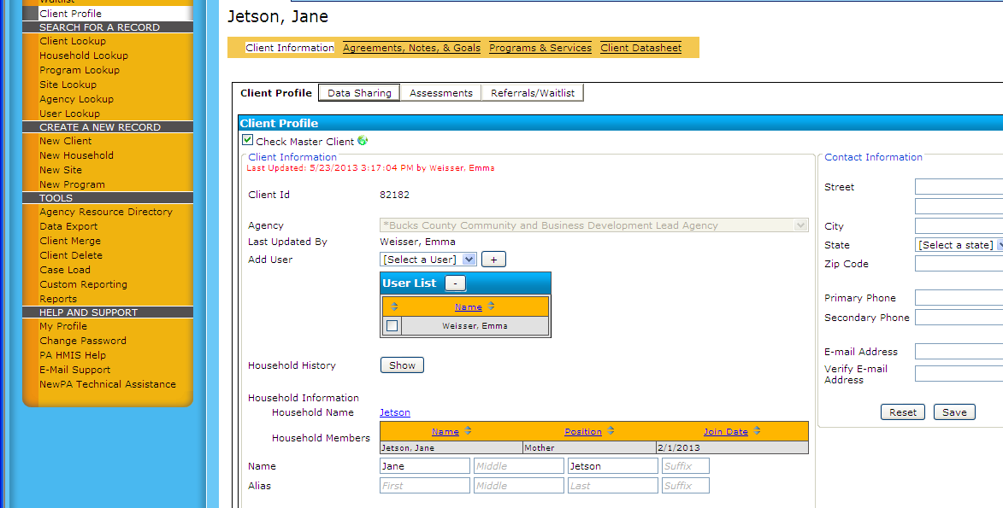

7. Create a New Client record for the child. Under Household, this time click the bubble marked “Existing.” The screen will then show a drop-down menu listing all of the households already created in your agency- simply scroll through the list and find the appropriate household.

8. Repeat steps 3 and 4 for the child: adjust the Join Date, and select the appropriate household position. Finish entering the rest of the information on that page, and click save. The household grid will now appear in the middle of the child’s profile page, with all of the household members listed. (So at this point, both the mother and child should appear in the household grid.)

This is a great time to verify that the Join Date is equal to the Program Entry Date for all household members.

