HMIS for Coordinated Assessment
Step 1: You receive an email notification stating that you have a pending referral.
It looks like this:
This is the referral notification number. You will need this number in order to locate the referral from your agency’s Incoming Referral list.
1031
Your goal is to accept the referral within 2 business days.
Time Commitment: 2 minutes.

- Log into HMIS.
- Click on Community Resources, Referrals.
- Click on the tab for Incoming referrals.

- Select the referral with the appropriate Referral ID (it matches the ID in your email).
Referral ID Number is the first column in the table labeled “Pending Referrals.”
You can sort the Referrals by clicking on the green arrows in the column header.
- Detailed info about the referral will appear. Scroll down, then click the button Accept Referral.
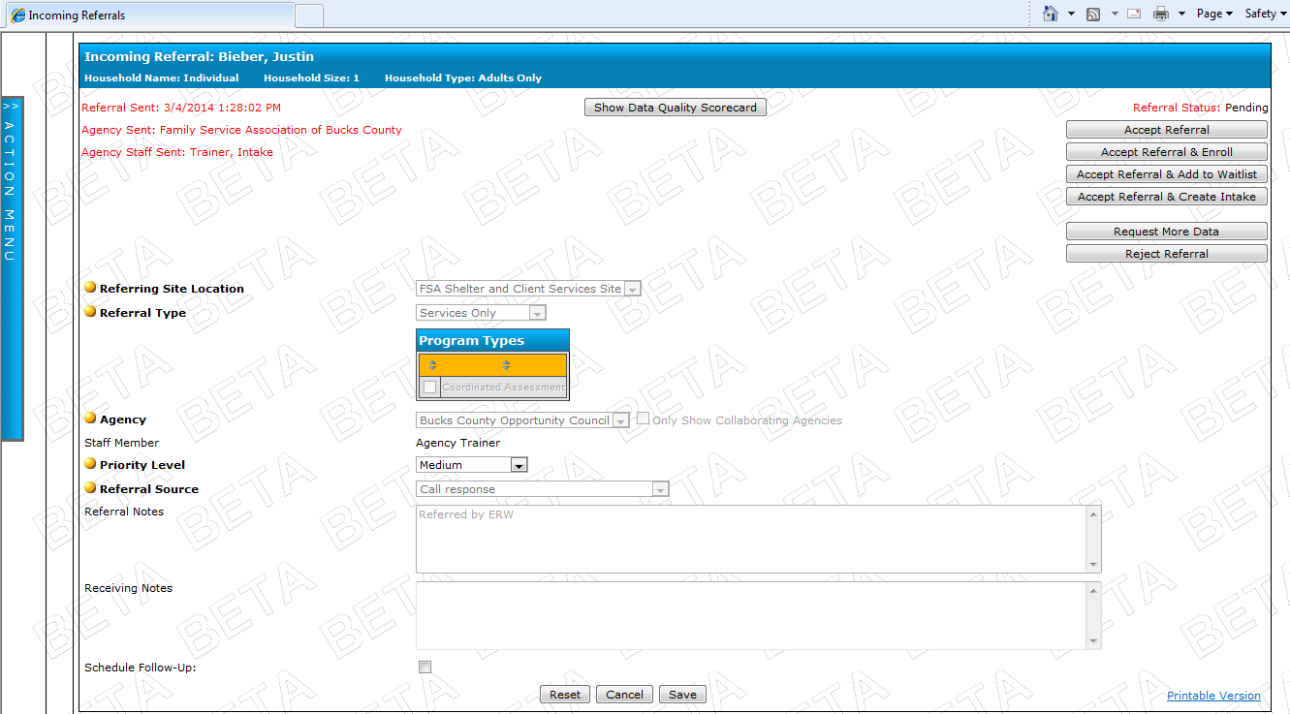
Client’s name
Information about the priority level and the referral notes will be listed here. This is how you know how quickly you should call the person back.
- Then the buttons on the right will gray out, and the Referral Status will be Accepted. You are done.

Step 2: You are ready to call the client back and complete the Eligibility Screening over the phone.
- Log into HMIS.
- Click on Client Management, Bucks County Housing Link.
- Click on Load Intake.
- Select the client’s name from the drop down menu.
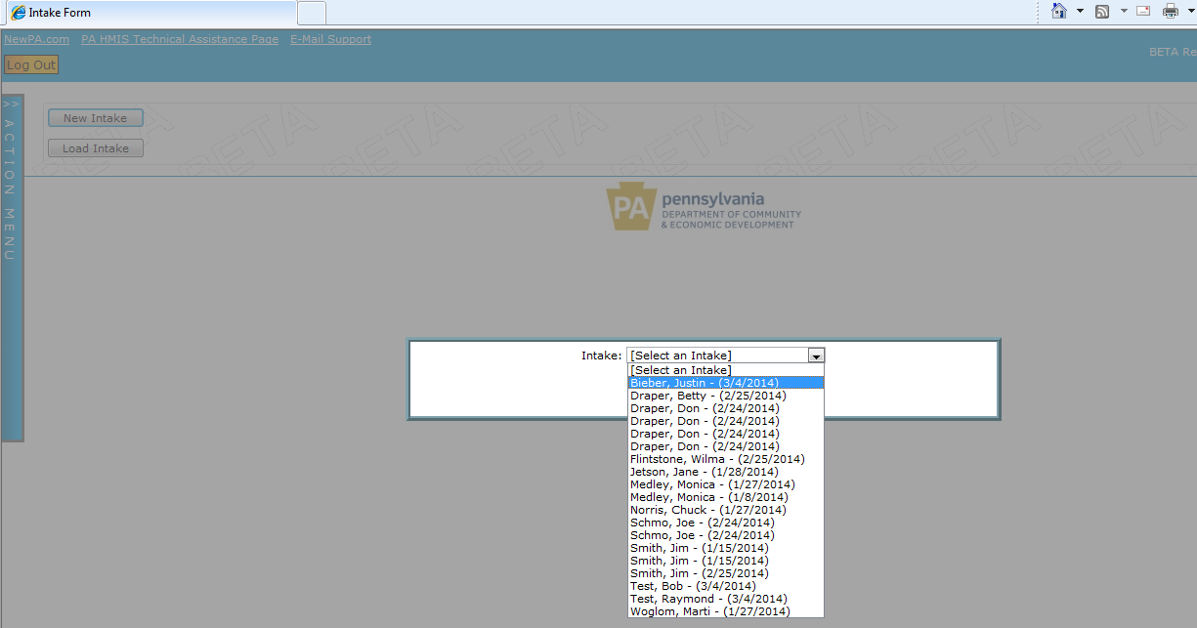
- Click Load.
- Click on the button View Last Call Screening to view the Call Center’s completed call screening.

Print the full call screening by clicking on the little icon that looks like a printer.
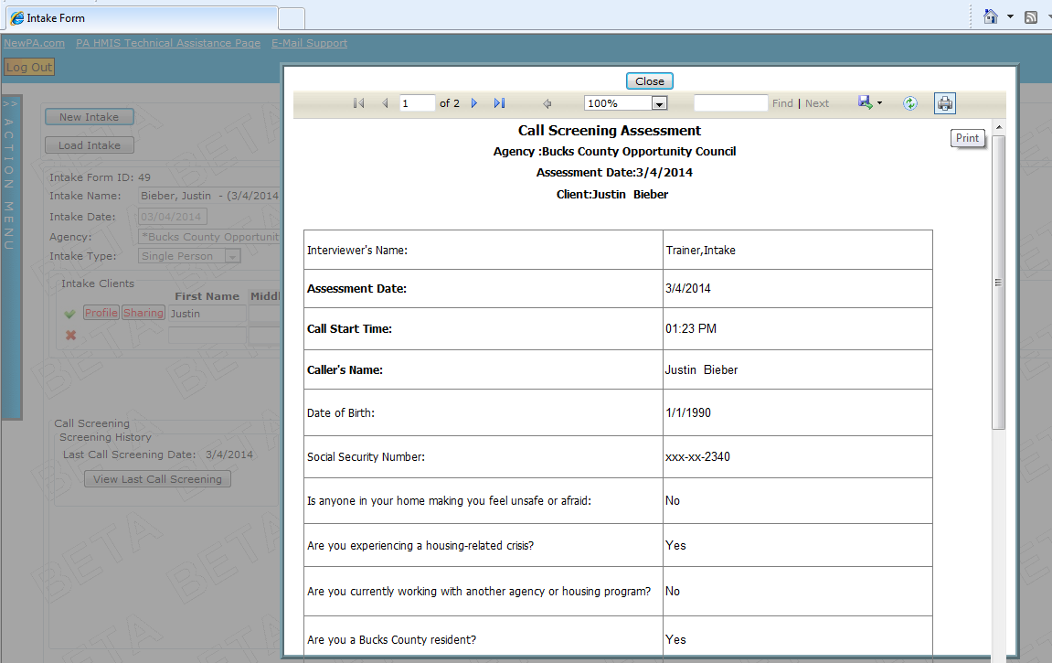

Then close the box by clicking the Close button.

- Ask the client if there are additional household members.

  - If there are, add those names one at a time into the text box below the Head of Household. You can check the box after DOB and SSN if the person refused to provide that for you at this time. Click Save.
Add the name, date of birth, social security number, and select gender.
Then click Save.
  - Now add the relationship for that person, and click Save.
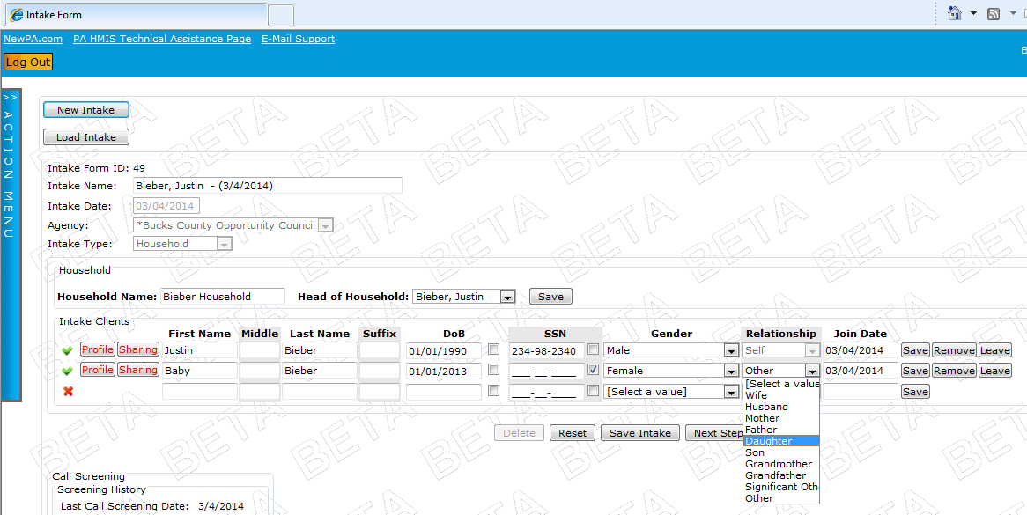
  - If you need to add more family members, continue steps (a) and (b) until you have added and saved each household member.

- Click on the button New Eligibility Screening to open up the Eligibility Screening form.
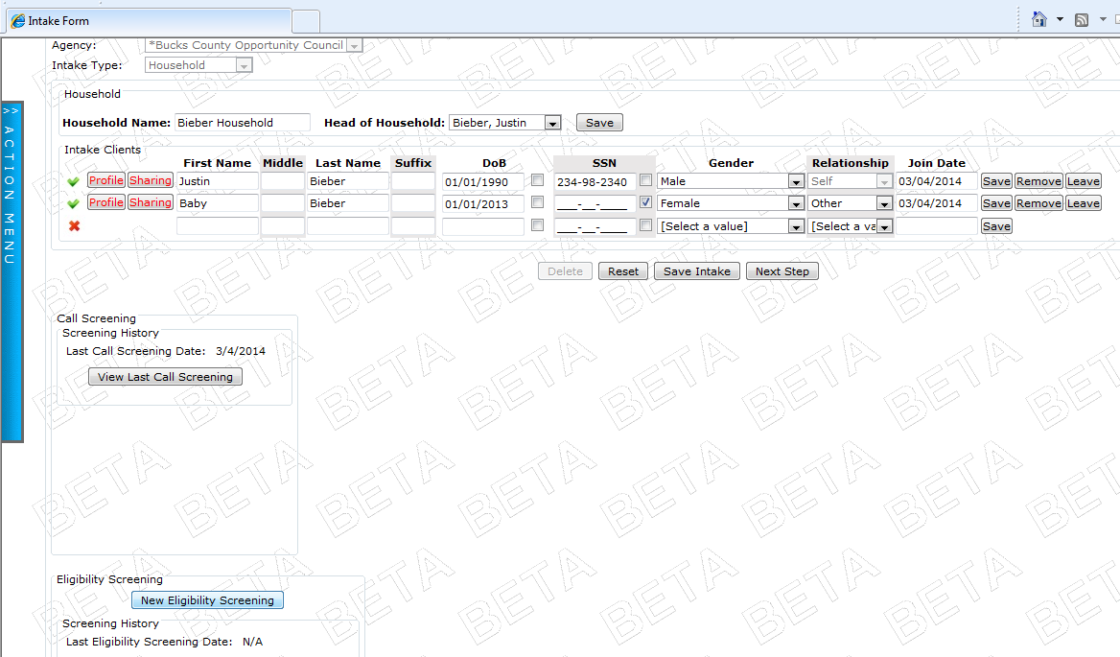
It looks like this:
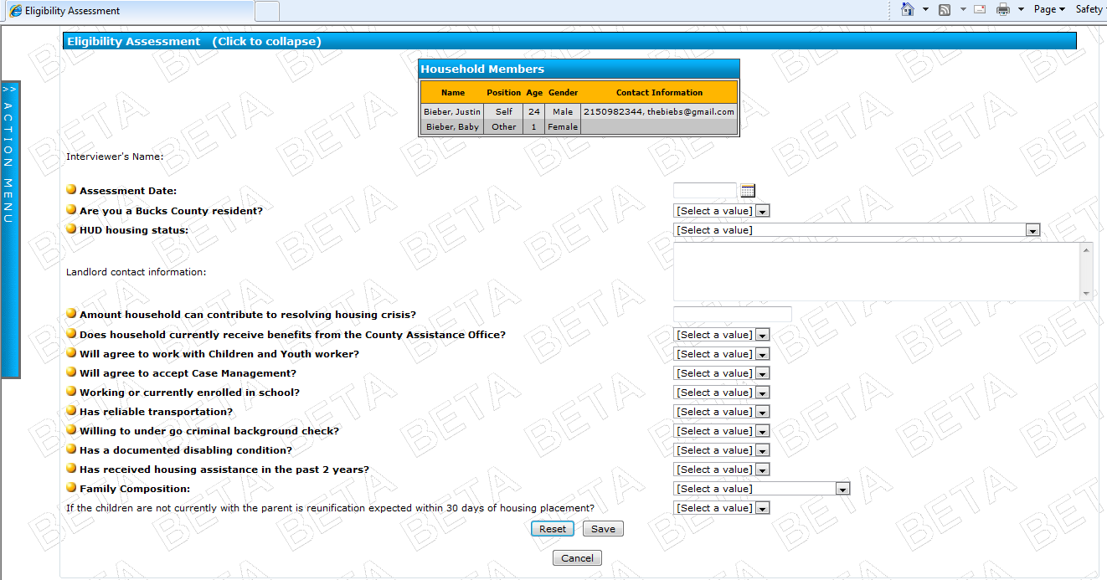

- Complete the Eligibility Screening by answering all of the questions that have a gold dot. Some answers that you put in may require additional questions to be answered. If that happens, be sure to answer those additional questions as well.
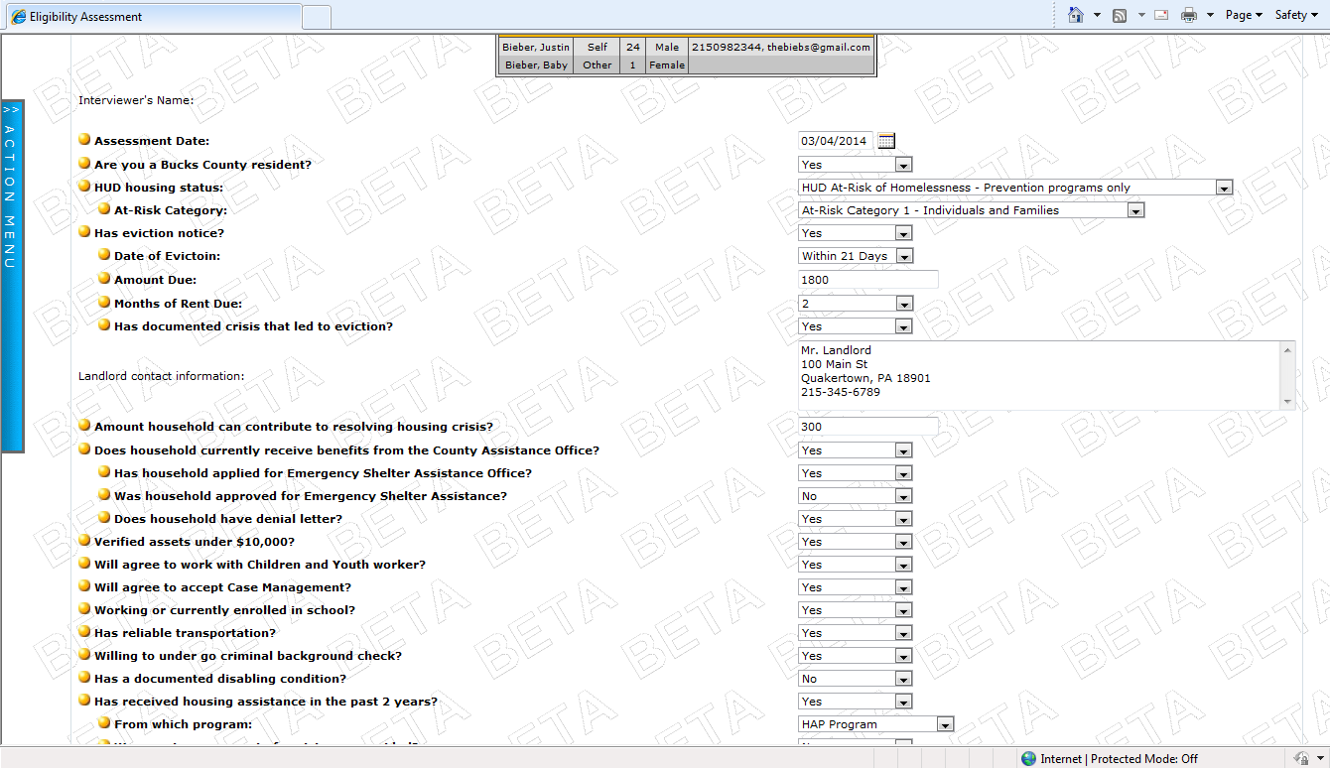
These additional questions popped up based on the Eviction and Benefits answers we provided.
This information is used to help HMIS (and you) make sure that people meet all of the eligibility requirements for a program before being referred.

- Click Save at the bottom of the page when you are done.
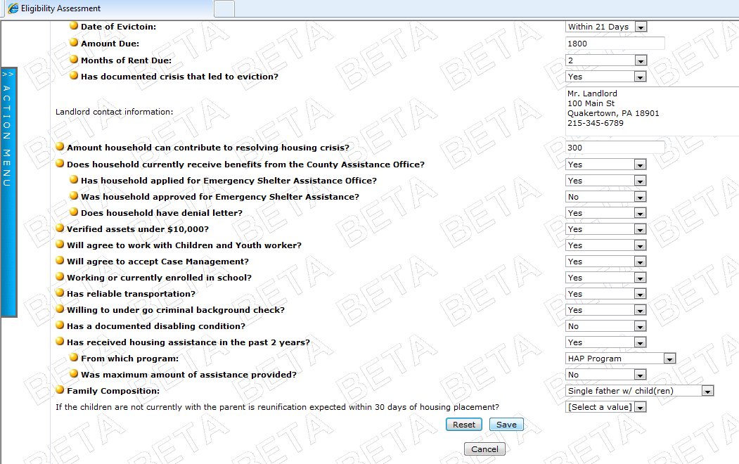

- This is how your screen will look when you click Save:
(A budget appears, and your Eligibility Screening gets saved as just one tab in the eligibility process)
(Note: if you didn’t answer all of the required questions, the red box will appear at the top of the screen to let you know which questions must still be completed.)
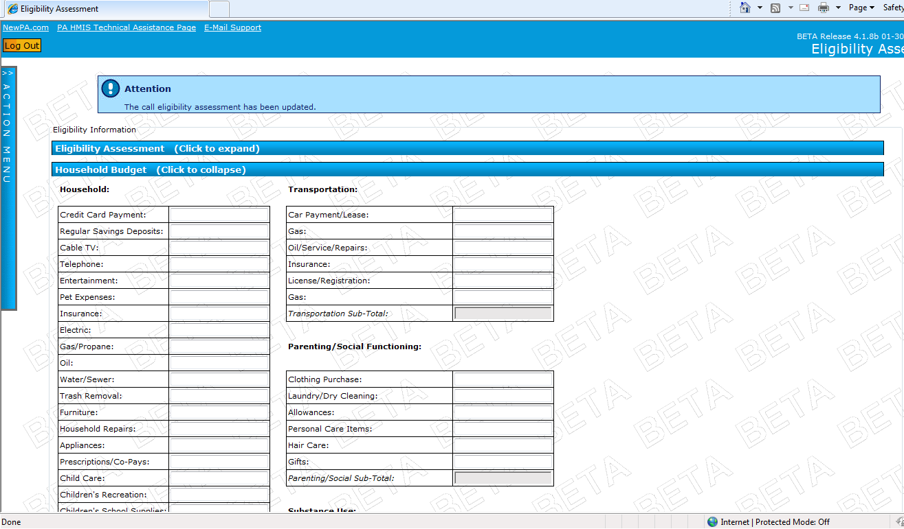
Your Eligibility Assessment is saved under this first tab marked Eligibility Assessment. You can open it again by clicking on the title, or close by clicking on the title again.
This budget is where you enter the income information that is used to determine income eligibility.

So, scroll down to the bottom where it says Gross Monthly Household Income, and enter their income.
Budget surplus/ deficit, Area Median Income, and Poverty Limit (FPIG) all get calculated automatically for you here.
Tip:
A budget is a good piece of information to send with a referral. It is highly recommended that you complete this with the client if possible, especially if completing a HAP application.

- Click Save.

- Most likely, at this time you need to know whether the person is eligible for prevention services (HAP), another program (so you will need to bring them in for a SPDAT), or not eligible for anything.

To help you make this decision, you can use the Eligibility Scorecard.

Scroll to the bottom of the page (the Document Check List will appear; you can ignore that for now). Click on the button labeled Eligibility Scorecard.
- The Eligibility Scorecard will appear in the screen. You will see which programs the person qualifies for based on their eligibility assessment.
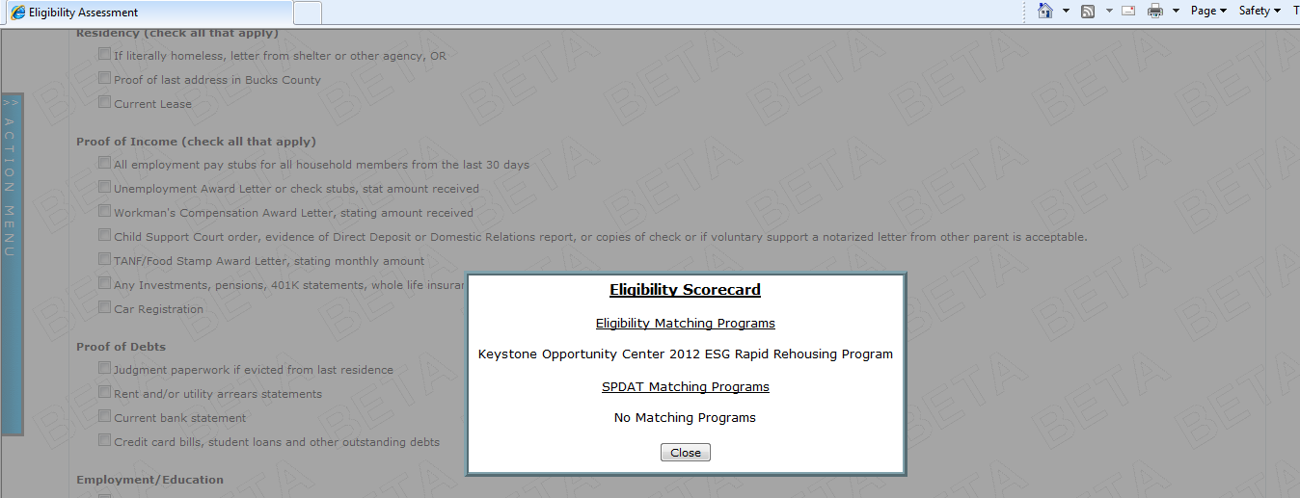
The SPDAT matching programs won’t appear until you actually input a SPDAT score (more on that next).

- Most likely, at this point you are either bringing the person in for an in-person appointment to make a HAP payment, complete the SPDAT and then make a referral, or are not referring them elsewhere because they are not eligible for anything through the Housing Link.

You can now close the Eligibility Scorecard, and exit out of HMIS until you are ready for Step 3: Completing the SPDAT.

Step 3: Entering the HUD Required Data Elements, aka Before you complete the SPDAT in HMIS.
You need to have the client complete the HMIS Release of Information (data sharing consent form) and complete the basic required data elements for each household member before you can enter the SPDAT data.
There are shortcuts to do this through the Housing Link pages.
So, your workflow at the in-person appointment should go like this:
- Have the client sign the HMIS Release of Information for each person in their household. Then enter the data sharing policy into HMIS for each member of the household:
  - Log into HMIS.
  - Click on Community Resources, Bucks County Housing Link.
  - Click on Load Intake.
  - Select the Client’s name from the dropdown menu and click Load.
  - Click on the button labeled Sharing next to the client’s name.
  - A pop-up will appear with the data sharing page. First you will enter the Domestic Violence status and current date, and click Save.
  - Then you will enter the data sharing permission level that the client agreed to by selecting the appropriate bubble, then scroll down and click Save. (If you are completing the SPDAT over the phone, and can’t get a signed release, just select ‘No Data Sharing.’)
  - You will be taken back to the household screen. Complete this step for each additional member.
- Complete the HUD required data elements for each person:
  - Click on the button labeled Profile next the client’s name.
    - A popup window will appear. Click on the text that says HUD Required Elements.
    - The box will expand and you will see the data elements appear. Complete them, then click Save.
    - You will be taken back to the household screen. If there are other family members, repeat the same process by clicking on the Profile button, then the HUD Data Elements.

Step 4: Completing the SPDAT in HMIS.
(If you are completing the SPDAT immediately after entering the data sharing and profile information, skip to Step 5 below)
- Log into HMIS.
- Click on Community Resources, Bucks County Housing Link.
- Click on Load Intake.
- Select the Client’s name from the dropdown menu and click Load.
- Scroll down the page and click the button that says Continue Eligibility Screening.
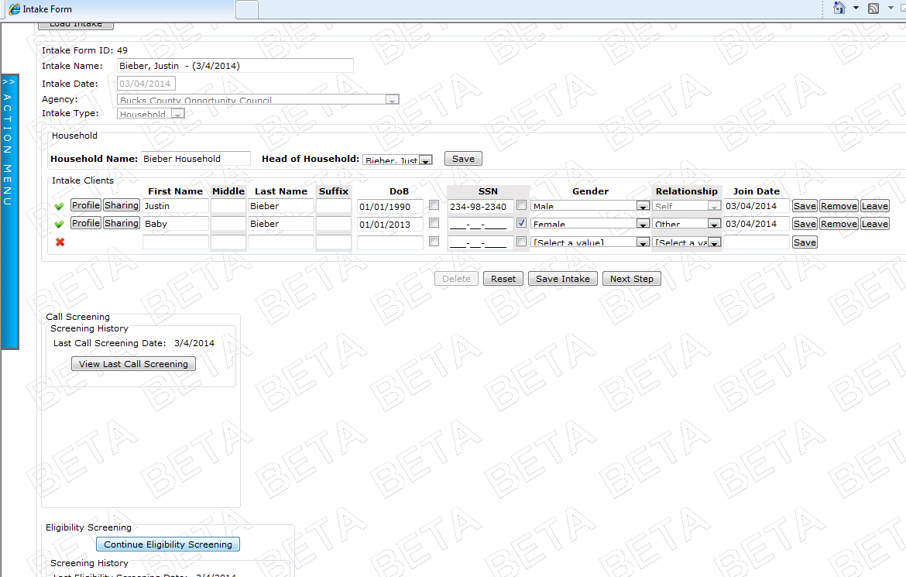
- You will be taken to the Eligibility Screening form that you already completed. It will look like this:
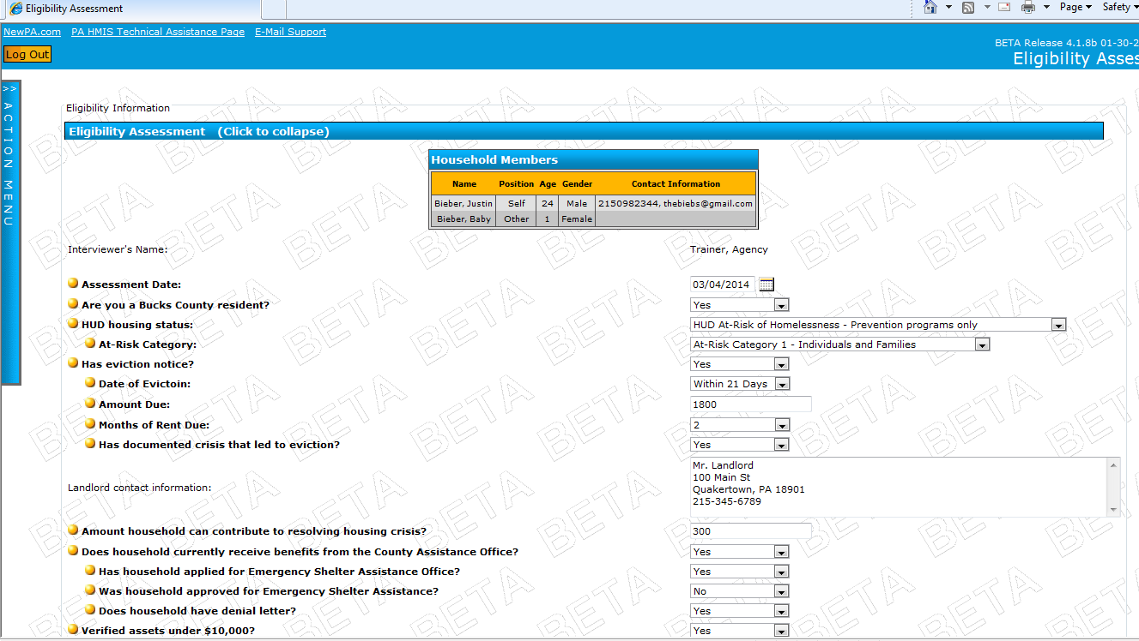

You can update or change any information here if you need to.

- Scroll down, and you will see the Household Budget and Document Checklist pages.

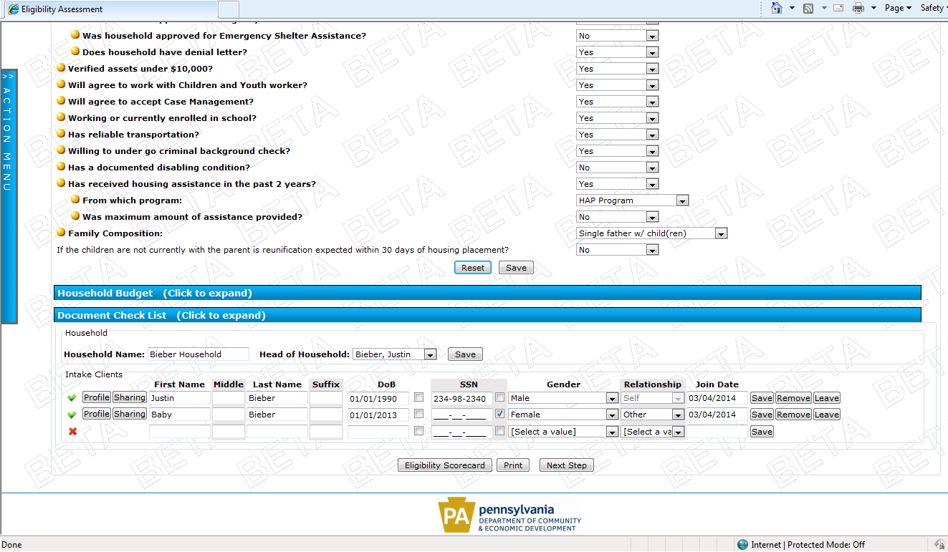

You can click on the text (where it says ‘Click to expand’) to view those pages. You can edit those pages now, too, if you need to.

- To open the SPDAT form, click on the button that says Next Step.
- You will see a pop-up window appear in the center of the screen, asking you what you want to do next:
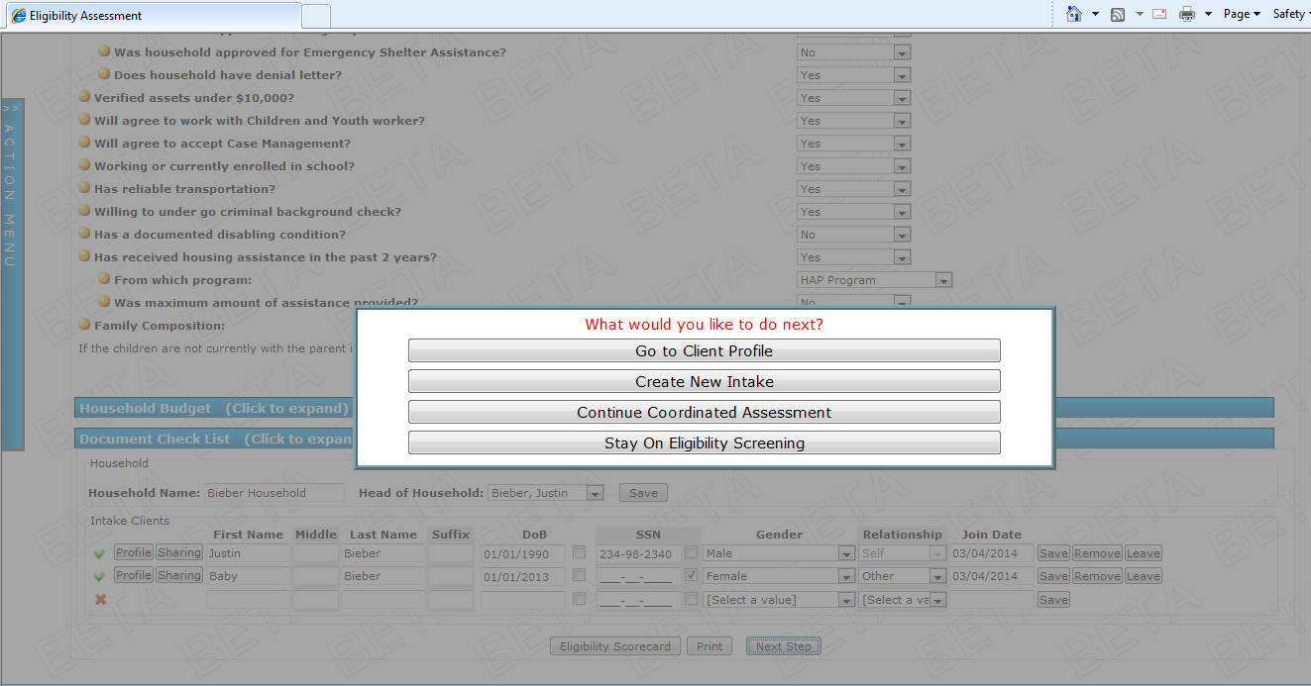
- You want to click Continue Coordinated Assessment.
- Now another pop-up window will appear. This one is asking if you want to complete any additional assessments at this time, in addition to the SPDAT. These additional assessments are the same HMIS assessments that you are used to completing (health, education, employment, income, benefits, etc).
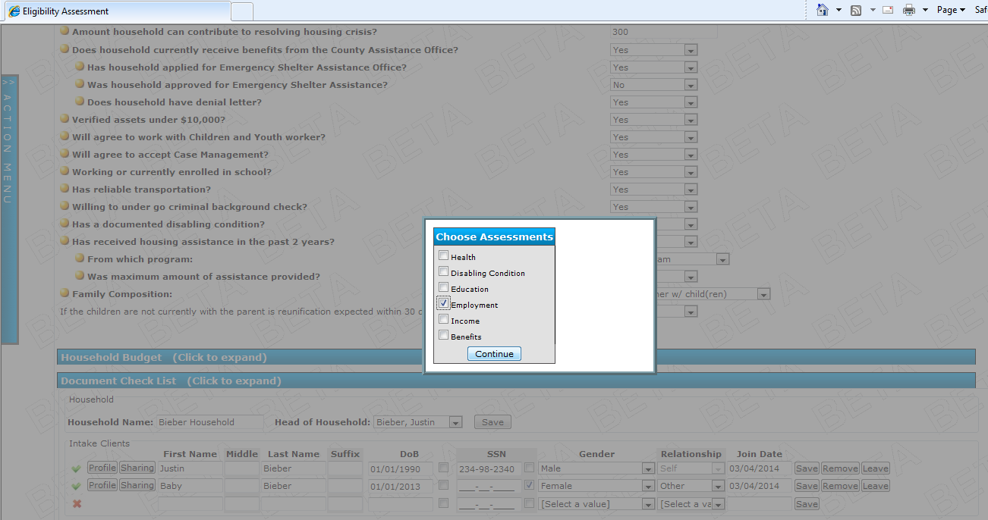
If you have the information to complete any of these now, check the box. If you don’t want to complete anything other than the SPDAT at this time, then just click Continue.

In this example, we want to add in the client’s employment information in addition to the SPDAT assessment.

- The HMIS assessments appear first. Since we chose employment, the employment assessment then appears for us to complete. This looks just like the assessment when we complete it for a program enrollment.
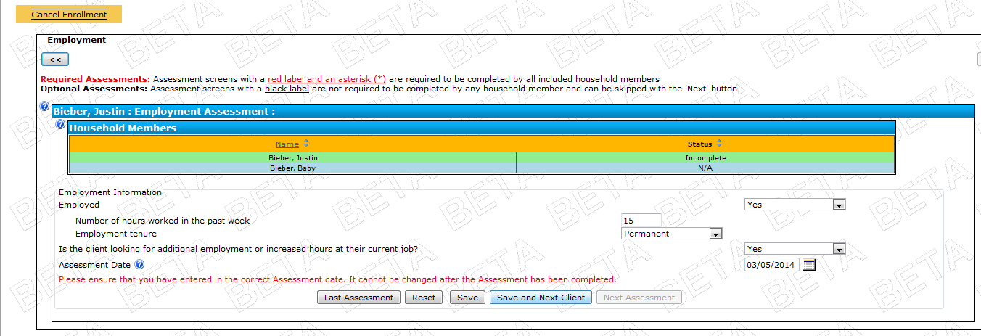

So we complete the assessment, and click Save and Next Client. Continue to do this for all of your clients and assessments.

- Once all of the HMIS assessments are done, the SPDAT form will appear. It looks like this:
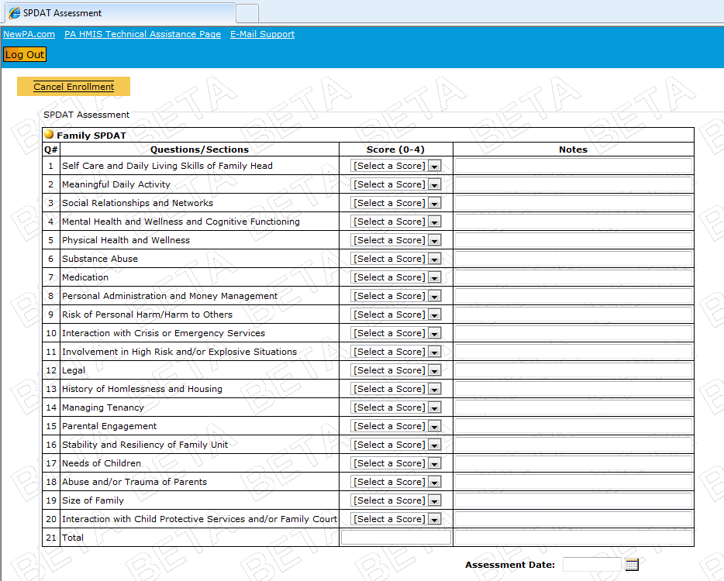

Note that HMIS knows whether you are completing the Family SPDAT or the Individual SPDAT based on the household composition that you selected on the Eligibility Screening form.

If you have 2 adults, HMIS will provide 2 Individual SPDAT’s for you.

- Select the scores for your household as appropriate. For any dimensions that are not listed on the pre-screen, enter a ‘0’. (See the attached sheet for matching the pre-screen categories to the full SPDAT categories)
- Then enter the Assessment Date, and click Save.
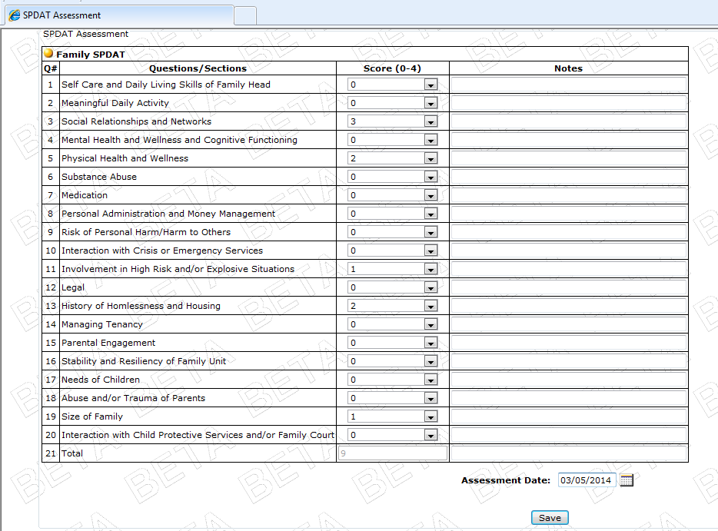
- From here, you can do a couple of things:
  - Check the Eligibility Program Match and SPDAT score match.
    - Click on the button Eligibility Scorecard, and the programs that match the person’s eligibility and SPDAT will appear.
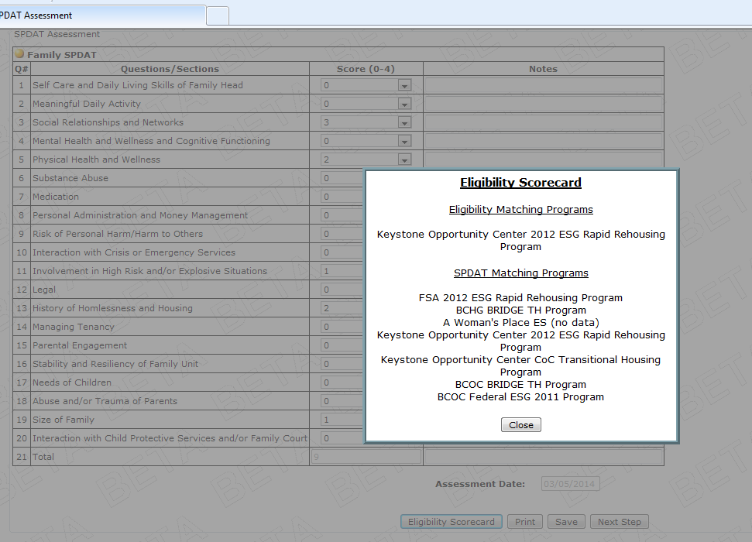
  - Refer the client to another agency’s program.
    - Click on the button Next Step.
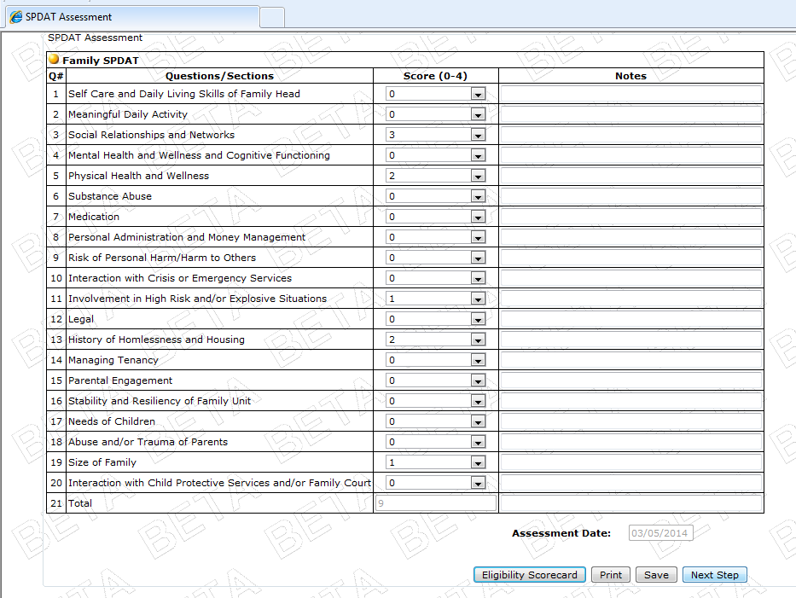
    - Click on the button Refer Client.
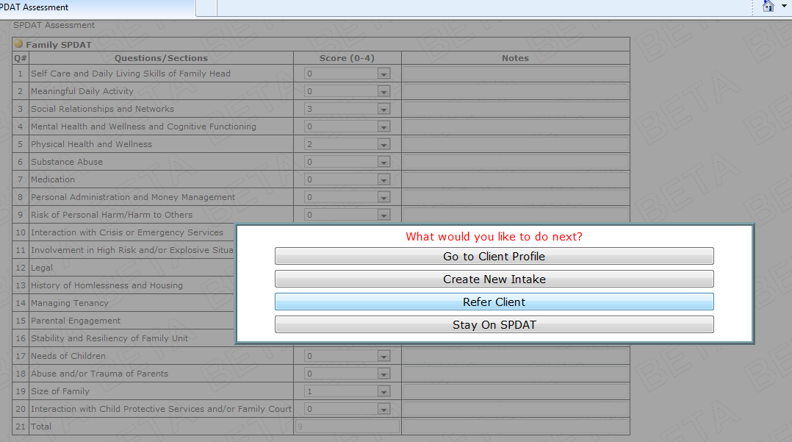
    - Then follow the steps for making a referral:

    - You’ll be taken to the referral page. Note that this is actually in the client’s profile.
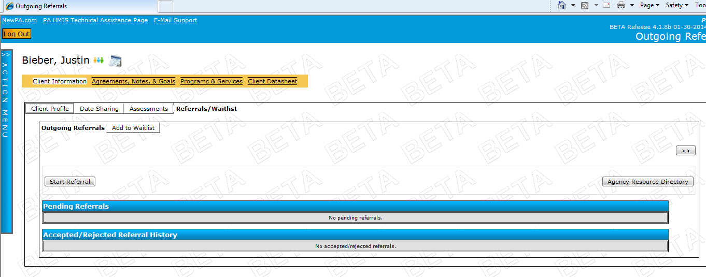
Look familiar?
    - Click the button Start Referral.
    - Select your Site and the Referral Type (housing and services).
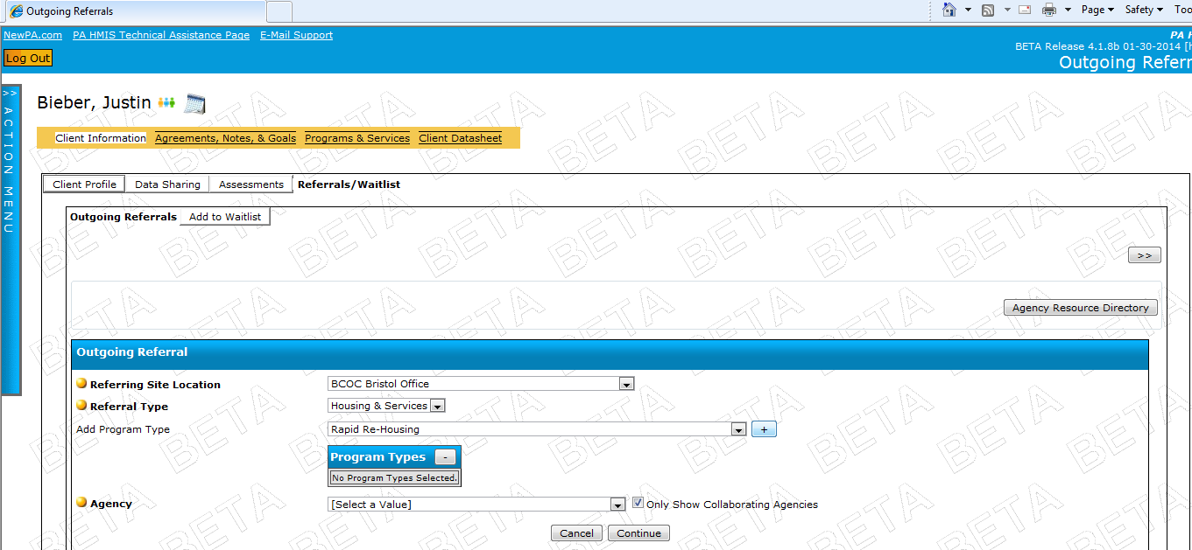

    - Then select the Program Type that you are referring to from the dropdown menu, and click the + button.
    - Then select the agency. (You can uncheck the ‘Only Show Collaborating Agencies’ box if the agency isn’t one of the Housing Link partners).
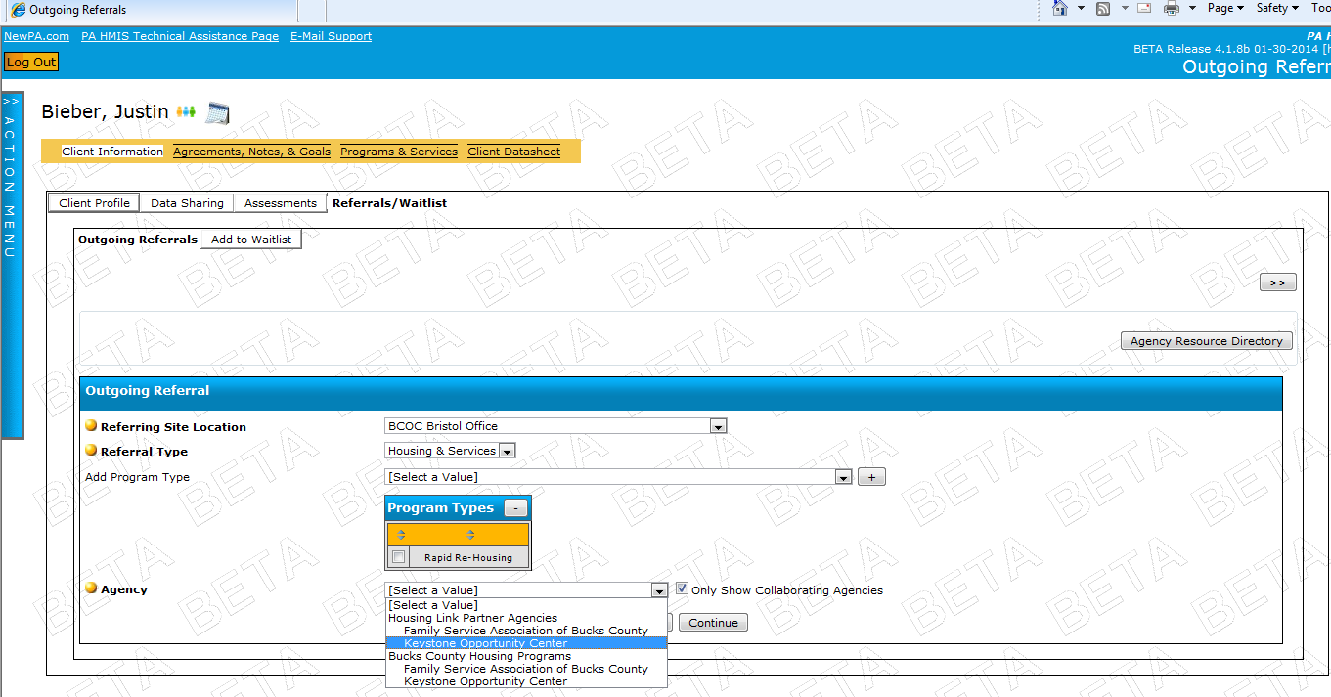
    - And click Continue.
    - A confirmation page will appear. Click Continue.
    - A final confirmation page will appear. Select the Staff person to send it to by clicking the button labeled Customize:
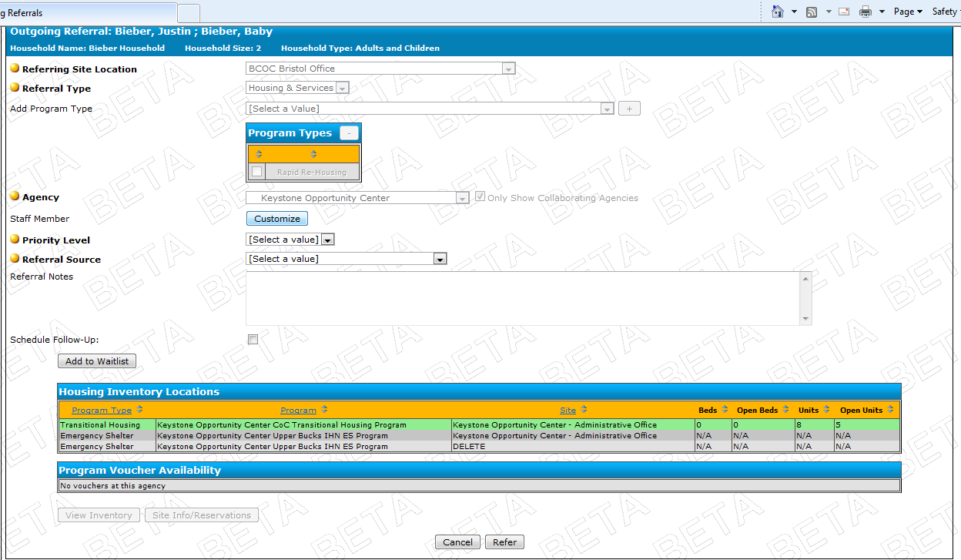
    - Then select the Priority Level, the Referral Source (Other Social Service Staff), click on the Site, and click Refer. You can also add any notes on the referral if you choose.
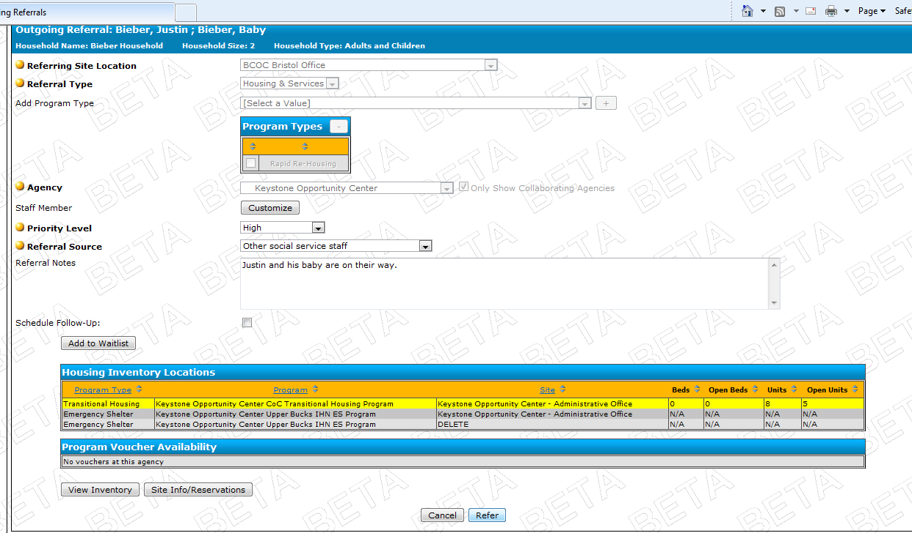
    - Your confirmation will appear at the bottom, are you done.

